
LOTUS ELITE ASSOCIATION of DRIVERS, FOLLOWERS, OWNERS, OPERATORS, TINKERERS and SUCHLIKE

27th February 2003

LEADFOOTS luncheon

Our first gathering for 2003 has been appropriately selected to occur on Tuesday, 1st April.
This is the week immediately following the historic race meeting at Oran Park, so the lie telling and level of excuses should be at an all time high.

The traditional venue at the Casa Bella Italian Restaurant, 172 Victoria Avenue, Chatswood, is again the meeting place for 12.30pm. Remember that it is also a BYO.

On this occasion, we will finally have in Australia, Mike Ostrov of Lotus Elite fame in the USA. Mike has especially timed his visit to coincide with the race meeting so that he might meet as many enthusiasts as possible and join us at a LEADFOOTS lunch. He has been involved in racing since the late ‘60s in a Super Seven, thru Formula Fords and other devices, serving as Racing Drivers Club President and many other SCCA duties. His cars are still running in historic meetings.

Mike has rebuilt more Climax engines than we have had lunches and his main problem is that he owns more Elites than anybody is entitled to have. By way of offsetting this imbalance, he makes many of his cars available on “driving days” to appropriate visitors - so remember this when talking with him.

There is also a danger of an unusual “Show and Tell” quiz for the real aficionados, with prizes on the day - Which is another reason why you need to advise me of your attendance intentions. The numbers are continuing to grow each time and space is becoming an issue, so it is important that you let me know either way.

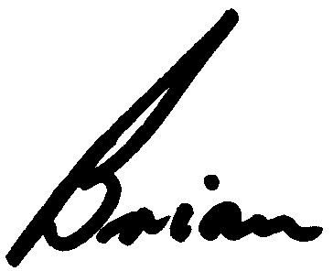
See you there,

Brian Caldersmith

18 Burnley Ave
North Turramurra 2074
Ph: 9449 1740
Fax: 9402 5740
Mobile: 0401 927 275
E-mail: BrianTC@bigpond.com

